**Домашнее задание №2**

1. SELECT name, telegram_contact FROM public.student

WHERE city IN ('Москва', 'Казань')

ORDER BY name DESC

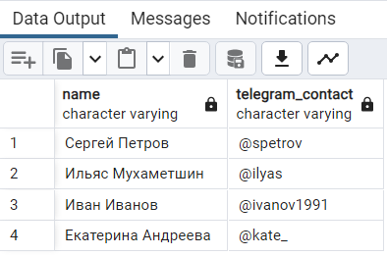

b. SELECT CONCAT('университет: ',name,'; ', 'колличество студентов: ', size)

AS "полная информация" from public.college

ORDER BY «полная информация» ASC

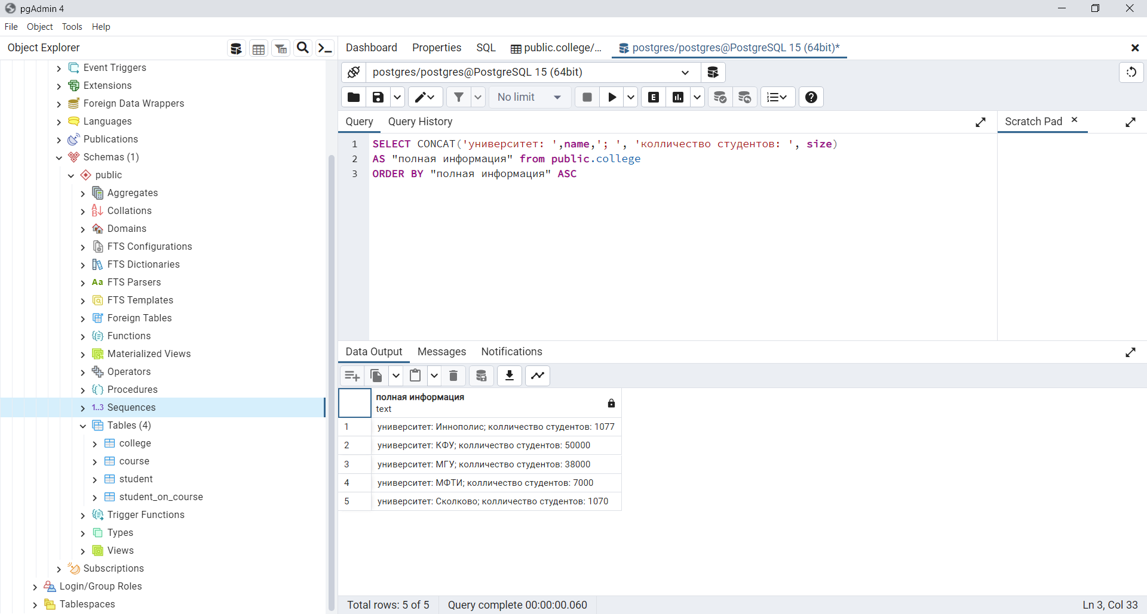

c. SELECT name, size FROM public.college

WHERE id IN (10, 30, 50)

ORDER BY size, name

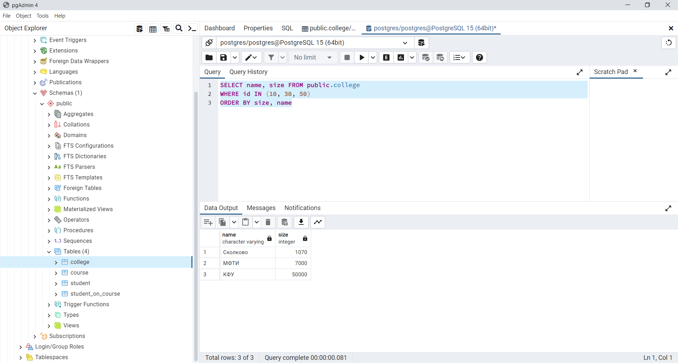

d.

SELECT name, size FROM public.college

WHERE id not IN (10, 30, 50)

ORDER BY size, name

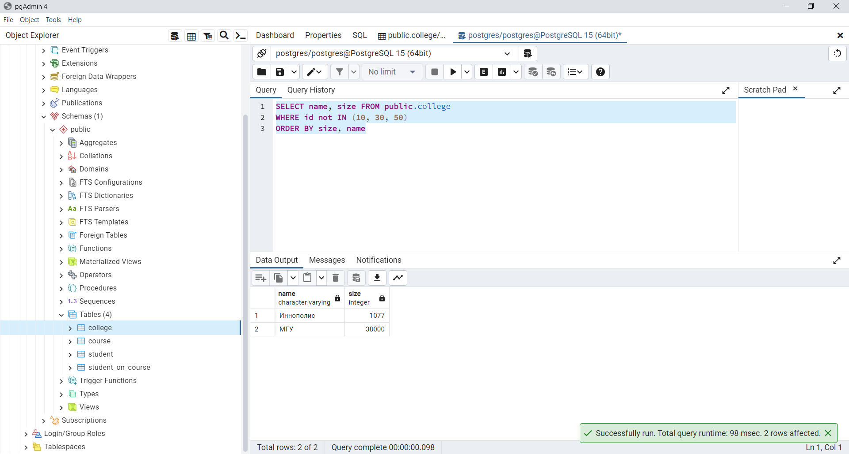

e.

SELECT name, amount_of_students FROM public.course

WHERE amount_of_students BETWEEN 27 and 310

order by name, amount_of_students desc

